[](http://commons.wikimedia.org/wiki/File:Epic.png)

@

Inpatient Nurse

Quick Start Guide

Table of Contents

Getting Started 5

Understand Epic terms 5

Manage Your Patient Assignments 7

See a list of patients on your unit 7

Maintain a list of your patients for this shift 8

Find recently discharged patients 8

Review the Chart 9

Preview your patients' charts 9

Review a patient's chart at a high level 10

Review lab results 12

Review notes 13

Review prior admissions and visits 14

Review the day's tasks 15

Administer Medications 16

Give a medication 17

Get dual sign-off 17

Troubleshoot Medication Administration 18

Handle unreadable barcodes 18

Send a message to pharmacy 18

Edit an incorrectly documented administration 18

Handle overdue meds 18

Document that a med was not given 19

Reschedule a single due time 19

Pull a med on override if the order isn't entered 20

Pull a med on override if the order isn't verified 21

Unlink incorrectly linked orders 21

Collect Labs 22

Change blood specimen collection status 22

Print labels and collect lab specimens 23

Document a point-of-care test (POCT) 24

Document Vitals and Assessments 25

Document vitals 26

Import and validate data from devices 28

Correct data that's already been filed 28

Mark a value as significant 29

Add a comment about one or more values 29

Document an assessment 30

Add a line, drain, or airway (LDA) to a flowsheet 31

Remove and complete an LDA 32

Add additional flowsheets 33

Document Intake and Output 34

Review intake and output totals 34

Review a patient's current infusions 35

Start an infusion 36

Change the rate of an infusion 37

Stop an infusion 37

Document giving an IV piggyback or bolus 38

Document intake from IVs 38

Document a PCA med 39

Admit a Patient 40

Release orders to be carried out on this unit 40

Understand phases of care 41

Document allergies 41

Document patient history 42

Review prior to admission (PTA) medications 43

Complete first assessments 44

Consider clinical suggestions 44

Confirm required documentation is complete 44

Document Care Plan and Patient Education 45

Create a care plan 45

Document progress on the Care Plan 46

Complete a learning assessment 48

Add education topics 48

Document educating the patient 48

Transfer a Patient from Another Unit 49

Confirm a patient's arrival in your unit 49

Make sure the physician reviewed medications 50

Release orders after a transfer 50

Manage Orders 51

Enter a new order 51

Modify or discontinue an order 52

Enter several similar orders at once 52

Discharge a Patient 53

Sign up a patient for MyChart 54

Print a visit summary for the patient 54

Nurse Cheat Sheet 55

Getting Started

Welcome to EpicCare Inpatient, Epic's electronic medical record. This guide walks you through an inpatient nurse's most common tasks in Epic.

Understand Epic terms

Throughout this guide, you'll see terms like activity and navigator used to refer to different parts of the screen. The image below shows what these terms refer to, and they are defined on the following page.

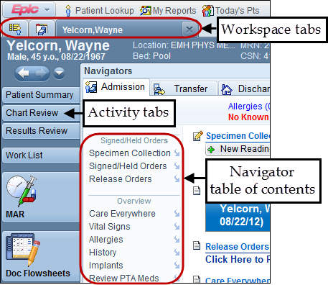

Workspace

A workspace is a collection of one or more activities. A patient's chart and Patient Lists are two examples of different workspaces. Select a workspace tab at the top of the screen to view that workspace.

Activity

An activity is a feature in Epic that supports a task, such as reviewing the patient's chart or writing a note. Activities are similar to tabs on a paper chart. Click an activity tab on the left side of the patient's chart to open that activity.

Some activities have a toolbar at the top (not shown in the previous image) with buttons for specific actions you can take in the activity. For example, in the Notes activity, there are toolbar buttons for creating and signing notes.

Navigator

During admission, transfer, and discharge, you do much of your work in a navigator. Navigators guide you through a variety of tasks, such as documenting the patient's medical history and allergies. To access a navigator, open the Navigator activity and select the Admission, Transfer, or Discharge tab.

Each navigator is made up of different sections, like Patient History and Allergies. The navigator table of contents lists all of the sections. Click the name of a section to open it. Click  to scroll to a section without opening it.

Manage Your Patient Assignments

See a list of patients on your unit

Use the Patient Lists activity to see lists of your patients and key information about them, such as patient location, any signed/held orders, etc.

Lists of your patients (My Lists) are marked with an  icon. Your organization creates two standard My Lists for you:

* The My Patients list shows only patients you work with. When you add yourself to a patient's treatment team, the patient appears on this list.
* The My Unit list shows patients currently in the unit you logged into. It updates automatically.

Other lists of patients (System Lists) are based on certain criteria, such as patients with a consult order or patients who are in a certain location. These lists are marked with an  icon.

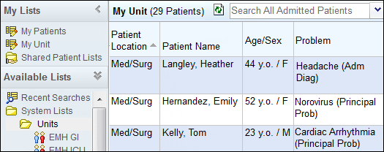

|  |  |
| --- | --- |
| Tip | Click a column header to sort patients by the information in that column. For example, click Patient Name to sort patients alphabetically by name.  To customize the columns that appear in a patient list, select the list, right click and click Properties. |

Maintain a list of your patients for this shift

Add yourself to the treatment team for the patients you're caring for during your shift by right-clicking each patient's name and selecting Assign Me. Then your patients appear on your personal My List, where you can easily find them.

At the end of your shift, right-click your patients and select End My Assignments to remove yourself from their treatment teams.

|  |  |
| --- | --- |
| Tip | To find a patient who's currently in a different unit, type her name in the Search All Admitted Patients field. |

|  |  |
| --- | --- |
| Tip | Update treatment team information for multiple patients by pressing the CTRL key while clicking their names. Then, right-click one of the names and select Assign Me or End My Assignments. |

|  |  |
| --- | --- |
| Tip | You can see the members of a patient's treatment team in the Treatment Team section of the Profile report. |

Find recently discharged patients

To find patients who were discharged within the last four days, search for them in Patient Lookup.

**Sign In**

You can also click on Sign In at the top, enter your contact and shift information, then select your patients and sign in.

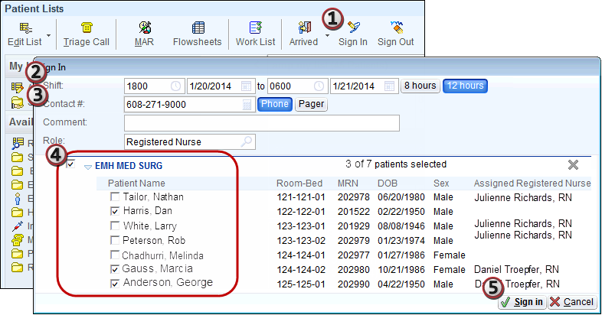

Review the Chart

Preview your patients' charts

In Patient Lists, there are two ways to view patient information without opening the chart:

A. Select a patient to view a report in the bottom pane. Click the report toolbar buttons to switch reports.

|  |  |
| --- | --- |
| Tip | Quickly identify your patient's PRN and scheduled meds along with their frequencies, doses, routes, and last administration times using the Due Meds report. |

B. Use the icons in each column to identify patients with overdue meds, outstanding documentation, unacknowledged orders, and more.

Double-click a patient to open his chart.

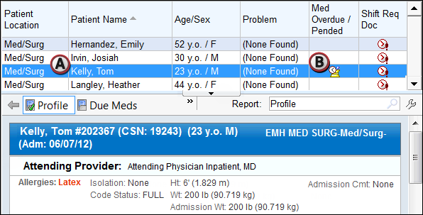

|  |  |
| --- | --- |
| Tip | While viewing a report you'll use often, click  and then click Add Current to add it to the report toolbar for quick access. |

Review a patient's chart at a high level

In Patient Lists, double-click a patient's name to open the chart to Patient Summary.

A. The Overview report includes a variety of information from the patient's current hospitalization, including medical problems, recent vital signs, I/O values, and lab results.

B. Click a button to view other reports, like Labs.

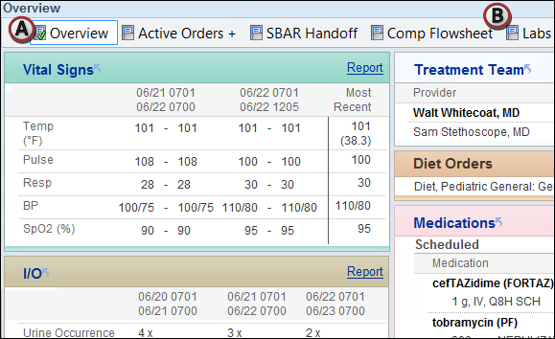

|  |  |
| --- | --- |
| Tip | Click a link in a section header to jump to the activity where you can document the information. For example, click I/O  to jump to the Intake/Output activity. |

Acknowledge orders

Acknowledge new and modified orders to indicate that you have seen and reviewed them. *This does not mean that you will be the one to carry out the order.* If you have concerns about the orders, acknowledge them and then contact the physician.

In the Orders to be Acknowledged section of Patient Summary, click Acknowledge All to acknowledge orders and remove them from this section of the report.

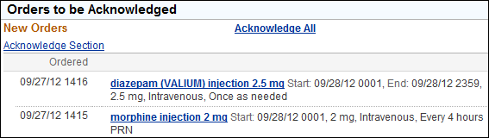

|  |  |
| --- | --- |
| Important Note | Orders are active whether or not you acknowledge them. Acknowledging orders is not the same as releasing them. For more information on releasing orders, refer to p. 59. |

|  |  |
| --- | --- |
| Tip | To see a list of all a patient's current orders, open the Orders activity. |

Review current medications

See an overview of the patient's current medications in the Medications section of the Overview report. To jump to the MAR, click the Medications link.

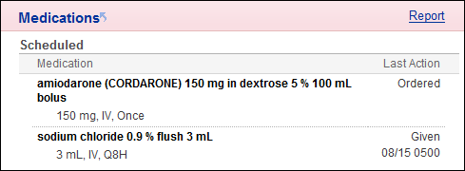

|  |  |
| --- | --- |
| Important Note | A last action of Ordered means the medication has not been given. |

Leave "sticky notes" in the chart

You can leave "sticky notes" for other clinicians at the top of the Overview report. These notes aren't part of the medical record and anyone can permanently delete them at any time.

1. Click the Comment link.
2. Enter your note, your name, and the date.

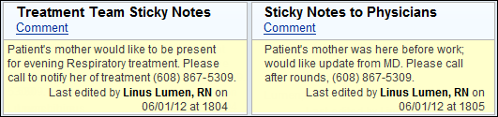

Review lab results

To see a patient's lab results since admission, open the Lab report in Patient Summary. It opens to the All view, which shows all data recorded. You can control how much data you see.

A. To expand or collapse the data, click an interval link. For example, click 4 Hrs to see four hours of data in each column.

B. To drill down for more detail in a specific interval, click a column header link. A plus sign appears next to a value if there is more data in the interval, and a ! sign appears if one of the hidden results is abnormal.

C. To view a different date, click the arrows next to the date. Or, enter a specific date in the Date () field.

|  |  |
| --- | --- |
| Important Note | When values are hidden, I/O cells display the total for that interval. All other cells display the last value documented in that interval. |

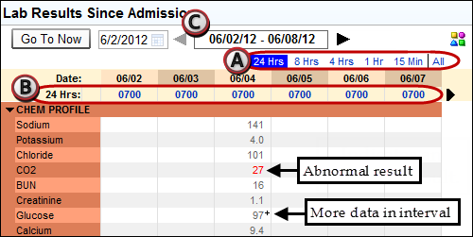

|  |  |
| --- | --- |
| Tip | In an interval view, the column headers show the start time of the interval. In the All view, they show the time the data was recorded. |

Review notes

View the patient's notes in the Notes activity. Select a note to view it below. To see a specific type of note, such as H&P, select the appropriate tab.

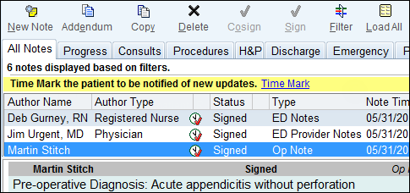

|  |  |
| --- | --- |
| Tip | To narrow down the list of notes by author type, such as physician, click  Filter. Sort the notes by clicking a column header, such as Note Time. |

|  |  |
| --- | --- |
| Tip | To know which notes are new, click Time Mark each time you finish your review. The next time you open the Notes activity, new notes will be marked with an  icon. |

Review prior admissions and visits

View information about a patient's past visits, notes, images, and more in the Chart Review activity.

1. Select the Encounters tab to view past visits.
2. Select a row to see a summary of the visit in the bottom pane. (Click  Preview if it doesn't appear.)
3. Select other tabs, like Notes, to view other information.

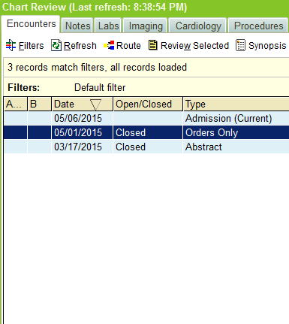

|  |  |
| --- | --- |
| Tip | Can't find the information you're looking for? Click Filters to narrow down the data. Choose to see only visits in a certain specialty, for example.  The filter options and criteria you see are based on the information in the patient's chart, so they vary by patient. |

Review the day's tasks

To see a list of tasks for all your patients, including upcoming medications, flowsheet documentation, and labs to collect, click  Work List in Patient Lists. To see tasks for just one patient, open the Work List in the chart.

A. Jump to the appropriate flowsheet row or med administration window for a task by clicking Doc.

B. Remove a task by clicking Skip.

C. To see only overdue tasks, click Overdue.

D. Click  Patient View or  Time View to organize your tasks by patient or task due time. You can also select a different list view, such as Room. The system saves your view preference, but this doesn't change what others see.

E. Apply filters to narrow down the list of tasks that appear. For example, you can view only medications or flowsheet documentation. The system doesn't save your filter preference.

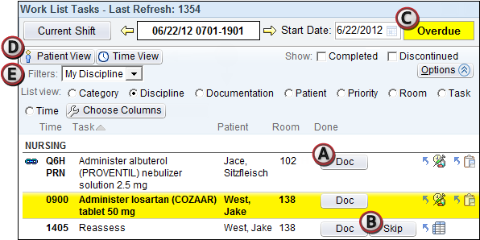

|  |  |
| --- | --- |
| Tip | Click  to jump to the MAR, or  to jump to Doc Flowsheets. |

Administer Medications

To open the MAR, scan the patient's wristband or click the MAR activity tab.

Due and documented medications appear on the MAR, along with time, action, and dose. The current hour column is highlighted.

A. Use tabs to filter the meds by type.

B. View all overdue meds (red bubbles) by clicking Overdue. Overdue administrations appear in red.

C. View past and future shifts by clicking the arrows.

D. View order details for a medication by clicking its row.

|  |  |
| --- | --- |
| Tip | Tan rows are completed meds, and yellow rows are discontinued meds. Click  to learn more about MAR colors. An  icon means the pharmacy hasn't verified the med yet. Click  to learn more about MAR icons. |

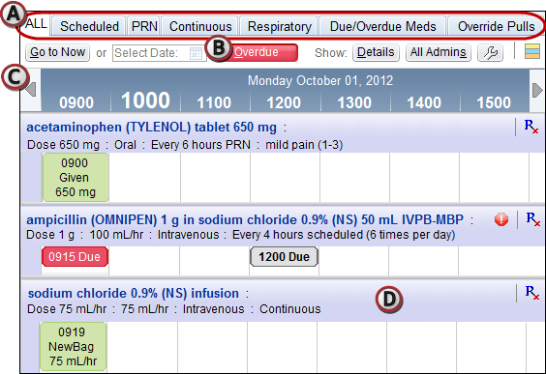

Give a medication

1. Scan the patient's wristband. The MAR opens.
2. Scan the medication you're administering.

* If the patient has multiple meds due at the same time, scan them all now.
* If the dose has multiple components, such as two Tylenol tablets, scan each component individually. The partial dose is denoted by an  icon.
* If the dose has linked medications, scan each component individually.
* If you're giving only part of the dispensed dose, click Partial Package, enter the dose you're actually giving, fill out other necessary details, and click  Accept.

|  |  |
| --- | --- |
| Important Note | If you can't scan the barcode, refer to p. 23. |

|  |  |
| --- | --- |
| Important Note | If you're documenting an intravenous medication, link the order to one of the patient's lines. For more information about documenting infusions, refer to p. 53. |

1. In the administration window, verify that the action and dose are correct for all meds. You can use the header to change the action, date/time, and comment for all meds.

|  |  |
| --- | --- |
| Tip | When you give certain meds, you can record additional information, like the pain score, from the administration window. This information is filed in Doc Flowsheets. |

1. 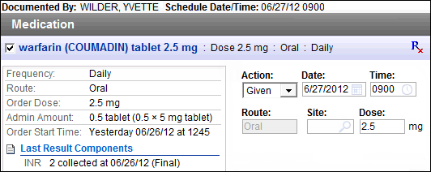Click  Accept. On the MAR, the time, action, and dose appear for each med you scanned.

Get dual sign-off

High-risk medications that require dual signoff, such as morphine, have an  icon on the MAR.

1. Document the administration as usual.
2. Click  Accept. A yellow Dual Signoff Summary banner appears.
3. Find another nurse to verify the five rights for this med.
4. If the information looks correct, the other nurse should click Sign Off and enter their user name and password to finish dual signoff.

Troubleshoot Medication Administration

Handle unreadable barcodes

1. Document the administration manually by clicking in the cell for the med's due time, selecting the correct Override reason, and clicking Accept.
2. Click  next to the order. Send a message to pharmacy with a Reason of Barcode Doesn't Scan.
3. Save the barcode and put it in a designated location so pharmacy can collect it.

Send a message to pharmacy

To reschedule more than one due time, to request a redispense of a medication, or to report a barcode that won't scan, send a message to the pharmacy instead of calling.

1. In the MAR, click  next to the med.
2. Enter a reason and write a message with more details.
3. Click Send.

|  |  |
| --- | --- |
| Tip | All messages sent in the past 12 hours appear in the message window. |

Edit an incorrectly documented administration

1. Click the administration bubble for the med that was incorrectly documented.
2. Select the Edit Administration check box. Click Accept.
3. Make your changes and click Accept.

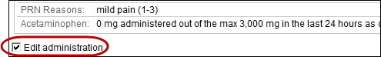

Handle overdue meds

If you give a medication more than 60 minutes after the due time, it's considered overdue. The system asks you to select which due time you're giving the med for to ensure that no doses are accidentally missed or added.

1. Scan the patient's wristband and the medication.
2. Select the original due time for the med.
3. In the administration window, enter the time when you actually gave the med.
4. Select an Off Schedule Reason.
5. Click Accept. The administration appears on the MAR.

Document that a med was not given

1. In the MAR, click the scheduled due time for the med. If the Patient Not Scanned warning appears, override it.
2. In the admin window, select an Action of Not Given.
3. In the Reason field, indicate why the med wasn't given.
4. Click Accept. The dose appears on the MAR with an action of Not Given.

Reschedule a single due time

If you give a dose far enough off-schedule, you might need to reschedule the next dose to avoid overmedicating the patient. For example, you might do this if you documented the originally scheduled dose as Not Given and you want a new dose clearly scheduled for later.

1. In the MAR, click the next scheduled dose for the med. Click Yes.
2. In the administration window, change the action to Due.
3. Change the Time field to reflect the new due time.
4. Enter an off-schedule reason of Dose Rescheduled and click Accept. A warning appears.
5. Click Move to move the dose to the new scheduled time.

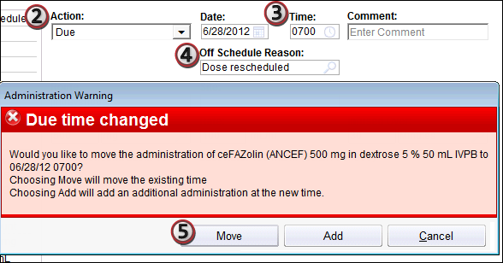

|  |  |
| --- | --- |
| Important Note | You can only manually reschedule one dose. The pharmacy must reschedule any later doses. |

Pull a med on override if the order isn't entered

If a medication order hasn't been entered into Epic yet, it doesn't appear on the patient's ADS profile. You can only dispense and administer the med if you pull it on override.

1. Pull the med on override, choosing the exact drug, form, and concentration from the original order.
2. Scan the patient's wristband and the med. The admin window opens.
3. Enter the route and other details. Confirm the dose is correct and click Accept.
4. Enter and sign an order to link the override pull to. The order must be exactly the same as the med you gave.
5. Select the Override Pulls MAR tab.
6. Show details for the override pull by clicking its row.
7. Click Link to related order.
8. Select the med you pulled on override.
9. Select the order you just entered.
10. Click Accept. The Administration window opens.
11. Administer the med as usual. An  icon appears in the administration bubble.

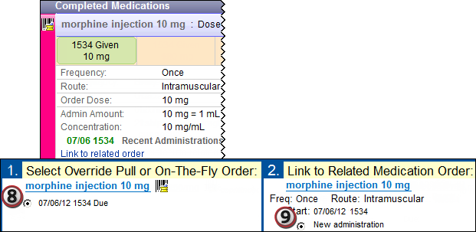

Pull a med on override if the order isn't verified

If a medication isn't verified by the pharmacy yet, it doesn't appear on the patient's chart. In that case, you can only pull the med if it's available on override.

1. Pull the med on override, choosing the exact drug, form, and concentration from the original order.
2. Select the Override Pulls tab on the MAR.
3. Click the medication's row to show more details.
4. Click Link to related order.

|  |  |
| --- | --- |
| Important Note | If there isn't a Link to related order link, you pulled the wrong product for this order. Return it to the cabinet to make this line disappear from the MAR. Then pull the correct product. |

1. Select the med you pulled on override.
2. Select the scheduled administration of the original order and click Accept. The Administration window opens.
3. Administer the med as usual. An  icon appears in the administration bubble.

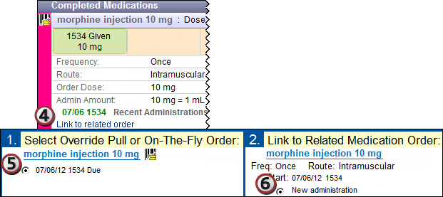

Unlink incorrectly linked orders

1. In the MAR, find the incorrectly linked med and click .
2. Click Unlink.

Collect Labs

Lab collection responsibilities don't change with Epic.

Labs that you need to collect appear on your Work List. These include the following:

* non-blood specimens
* blood specimens that are labeled Unit Collect
* point-of-care tests (POCT)

Most routine blood labs are collected by a lab technician or phlebotomist, so they don't appear on your Work List and you don't need to act on them.

Change blood specimen collection status

If you need to change who should collect future specimens, use the Specimen Collection flowsheet rows.

1. In Doc Flowsheets, select the IV assessment tab.
2. In the Specimen Collection flowsheet row, enter Unit Collect or Lab Collect.

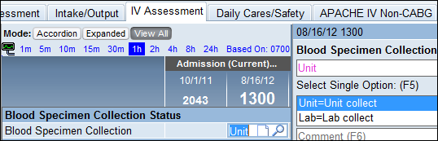

|  |  |
| --- | --- |
| Important Note | This collection status applies to all new labs. It does not affect labs that already appear on your work list as needing to be collected. |

Print labels and collect lab specimens

1. On the Work List, click Print Label next to the appropriate task. The Print Label window opens.
2. Select the check boxes next to the labels you want to print and click Accept. The labels print at the nearest printer.

|  |  |
| --- | --- |
| Important Note | Only print multiple labels at once if you're actually collecting all the specimens at the same time.  If, for example, you do one blood draw at 9:00 and a second draw at 10:00, respect those different collection times by documenting the tasks separately. |

1. When you have the specimen from the patient, click Collect next to the appropriate task.
2. Scan the patient.
3. Scan the specimen.
4. In the Collect window, document when, how, and by whom each specimen was obtained.
5. Click Accept. The task disappears from your Work List.

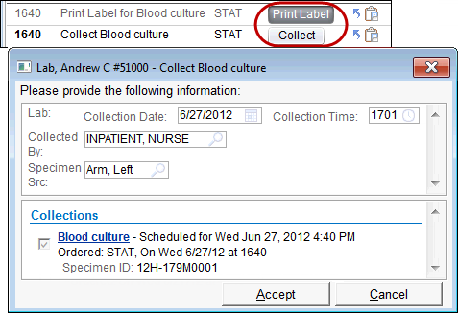

Document a point-of-care test (POCT)

Use a handheld device

1. Find the test on your Work List.
2. Perform the test using the device.
3. Dock the device. The patient's results are automatically transferred to the lab system and the patient's chart.
4. Click Done next to the task on the Work List.

Manually enter results

1. Find the test on your Work List.
2. Click the  icon.
3. In the Enter/Edit Results window, select the test you are performing and click  Edit.
4. Fill out all required and relevant fields and set the Status to Final Result.
5. Click Accept. The task drops off your Work List.

Document Vitals and Assessments

Use Doc Flowsheets to document a patient's assessments. To open it, select a patient from Patient Lists and click  Doc Flowsheets, or select the Doc Flowsheets activity tab in a patient's chart.

A. Flowsheet tabs: Commonly used flowsheets.

B. Table of contents: Shows the groups in the flowsheet. Click a group name to jump to the related documentation.

C. Flowsheet cells: View previous documentation and document new assessments here. Each documentation time has its own column, and each assessment has its own row.

D. Details sidebar: This sidebar shows you the options you can choose from as you document in each cell, and you can use it to enter data. Values you enter here appear in the flowsheet cells.

|  |  |
| --- | --- |
| Tip | If you are interrupted while documenting, click  Jump to where I left off next to the TOC when you return to the flowsheet. This opens the last cell you documented in. |

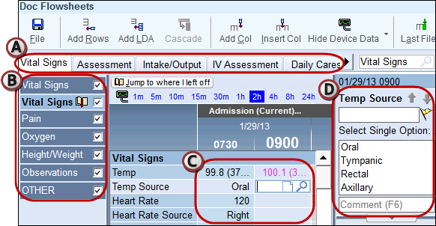

Document vitals

1. Select the Vital Signs tab.
2. Add a column for the time when you performed the assessment.

* Click Add Col on the activity toolbar to add a column for an assessment you performed just now.
* Click Insert Col on the activity toolbar to add a column and specify the time when you recorded vitals earlier in the day.

1. Enter or select values in the Details report. Remember to include units when needed.
2. When you're finished, go on to the next task. The system saves the data automatically.

Control how much flowsheet data you see

Select different viewing modes at the top of Doc Flowsheets to adjust the columns in a flowsheet.

A. View All: View a column for each time data was recorded. This view is selected automatically.

B. Expanded: View columns in regular increments, whether or not there is data for a given time. Click a time link to adjust the increment. For example, click 4h to show columns for 0300, 0700, and 1100. This view can help you remember to document assessments at certain times.

C. Accordion: View multiple columns of data collapsed into one column for a given time interval, or click the column to expand the columns again. The columns show data you documented at any point during each interval. Click a time link to adjust the interval shown in the collapsed columns. For example, click 4 h to show columns for 4-hour periods of time, such as 0301-0700, 0701-1100, and 1101-1500. Use this view for patients with lots of data that you might need to examine more closely.

|  |  |
| --- | --- |
| Tip | In accordion mode, a + sign appears next to a value if there is more data for that interval. Click the column header to see more detailed data. |

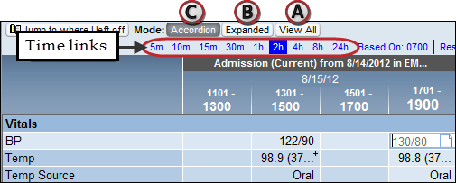

Document more quickly with the Details sidebar

Use the Details report to quickly view flowsheet options, select the appropriate values, and advance to the next row. The values you document appear in the appropriate flowsheet cells.

A. Enter numeric values here for vital signs such as temperature and blood pressure.

B. Left-click to select multiple options, then right-click to accept your options and move to the next row. In single-select rows, left-clicking moves you to the next row automatically.

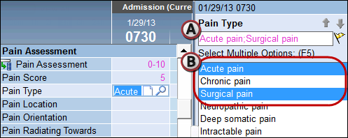

|  |  |
| --- | --- |
| Tip | Try the mnemonic "left-click to pick, right-click to stick" to remember which mouse button to use. |

Import and validate data from devices

Instead of entering vitals manually, you can import data from devices like monitors and vents. When you do this, you must validate the data before it's filed to the chart. This helps avoid errors.

1. In Doc Flowsheets, click  Show Device Data. The button changes to Hide Device Data after you click it. Device data appears in brown in the appropriate flowsheet rows.
2. Click the time links to choose how often you want to import data from the monitor.
3. Verify that the readings make sense. For example, if the patient's documented heart rate is 300, the monitor is probably malfunctioning. To fix incorrect data, click the value and change it manually.
4. Select the columns you've validated and file them, then the data turns from brown to black.

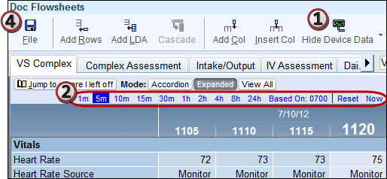

|  |  |
| --- | --- |
| Important Note | Data can only be imported for your patient when Epic shows him in the bed the device is attached to. If you can't import a patient's device data, make sure that Epic has been updated to reflect the patient's current location. Confirm his location in Patient Lists and correct it if needed. |

Correct data that's already been filed

To correct a mistake in filed flowsheet data, whether manually entered or recorded through a device, select the value that you want to change and enter the new value. A record of the change appears in the Details window under a Show Audit heading.

Mark a value as significant

To help physicians notice a value while rounding on the patient, right-click the value and select Significant Data. The cell turns yellow and the value is highlighted in physician reports. For example, if the patient's blood pressure has been low but becomes high, you might mark the value significant.

To remove the significant indicator for a value, right-click the cell again and select No Longer Significant.

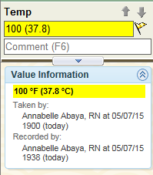

Add a comment about one or more values

1. Click the cell you want to comment on and click .
2. Enter your comment and click Accept. The value now appears with three blue lines on the right side: .
3. To read the comment, hover over the cell or click it.

|  |  |
| --- | --- |
| Tip | You can record comments anywhere you seein Hyperspace. |

To leave the same comment for multiple values, write a flowsheet note.

1. Select the cells you want to write a note about.
2. Right-click the selected values and select New Note. The Flowsheet Note window opens.
3. Click  Insert Data to insert the values you selected.
4. Enter any additional comments and click Sign. An  icon appears next to the headers of columns related to the note, and the note appears in the Notes activity.

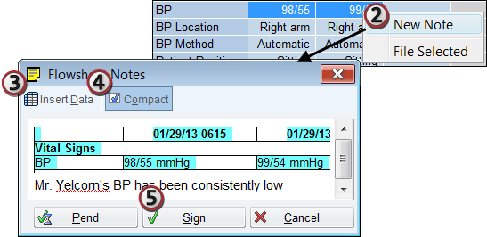

Document an assessment

In Doc Flowsheets, select the Assessment tab to complete a head-to-toe assessment. Add a column for the time when you performed the assessment and document your findings for each body system.

A. If the assessment for a body system is normal, enter "WDL" for "Within Defined Limits."

B. If the assessment is abnormal, enter "X" for "Exceptions to WDL." New rows cascade for you to enter more details about the abnormalities.

C. You can add additional rows for an assessment by clicking .

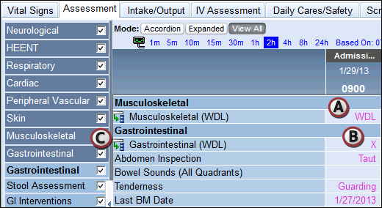

|  |  |
| --- | --- |
| Tip | If a flowsheet row doesn't apply to a patient or you added it by mistake, you can remove it by right-clicking it and selecting Remove. You can only remove flowsheet rows that don't contain data. |

Add a line, drain, or airway (LDA) to a flowsheet

Lines, drains, airways, tubes, and wounds (abbreviated LDAs) are all documented in flowsheets. Different types of LDAs are documented on the following flowsheets:

Add rows for each LDA you need to document.

1. In Doc Flowsheets, select the appropriate flowsheet tab. For example, to document a colostomy, select the Intake/Output tab.
2. Click  Add LDA. The Lines, Drains, Airways, Tubes, and Wounds Properties window opens.
3. Search for the LDA and click Accept. Click  to see a list of available LDAs. Only LDAs for the current flowsheet appear in the search results.
4. Enter the placement date and time and any other relevant information.
5. Click Accept to add the LDA to the flowsheet.

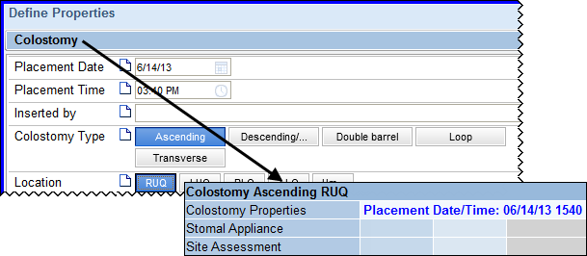

Remove and complete an LDA

To indicate that an LDA is no longer on the patient, document removing it. Complete an LDA to indicate that it doesn't need further documentation.

Most of the time, you should document removing and completing LDAs at the same time. For example, if you take out a patient's feeding tube before discharge, you must document both removing and completing the tube.

If a patient is discharged with an active LDA, don't document removing it. Instead, complete it to indicate that you no longer need to document on it. For example, complete the IV if a patient leaves the hospital with it.

Remove an LDA

1. Click the Properties row for the LDA you want to remove. A Properties window appears.
2. If the fields are not editable, click Edit.
3. Enter a removal date, time, and reason.
4. Click Accept.

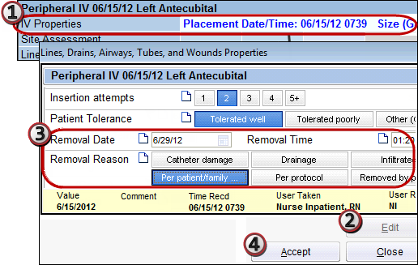

Complete an LDA

1. Right-click the LDA's title row in the flowsheet.
2. Select Complete. The LDA disappears from the flowsheet.

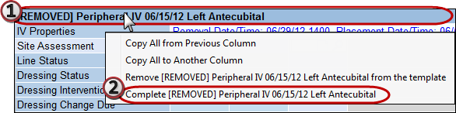

Add additional flowsheets

If you need to document an assessment but can't find the appropriate flowsheet, you can search for it. For example, you might need to document a patient's restraints, but none of the default flowsheet tabs include rows for restraints.

1. In Doc Flowsheets, enter a keyword, such as "restraints," in the  Search field. A list of related results appears.
2. Double-click the appropriate flowsheet to add it as a tab in Doc Flowsheets.

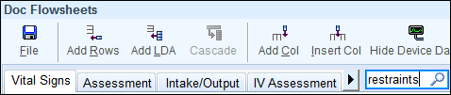

Document Intake and Output

Use the Intake/Output tab in Doc Flowsheets to document all intake and output, including the following:

* Basic I/O (measured and unmeasured)
* Output from drains, tubes, and wounds
* Intake from IVs, tubes, and other lines

Document I/O before transfer or discharge and throughout your shift as usual.

|  |  |
| --- | --- |
| Important Note | To document I/O at the end of your shift, insert a column before the shift's end. Otherwise, the I/O will be included in the next shift's totals. |

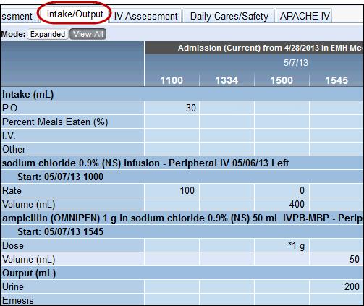

Review intake and output totals

Review the patient's I/O in the Intake/Output activity (not Doc Flowsheets). For each shift, you can see a summary of the values from Doc Flowsheets, and the total and net I/O are automatically calculated.

A. To graph I/O, click Graph or Cumulative.

B. To change the amount of time shown in a column, select a different Interval.

C. To see I/O totals for other days, click the arrows.

D. To see sources contributing to an input or output, click the blue arrows to expand.

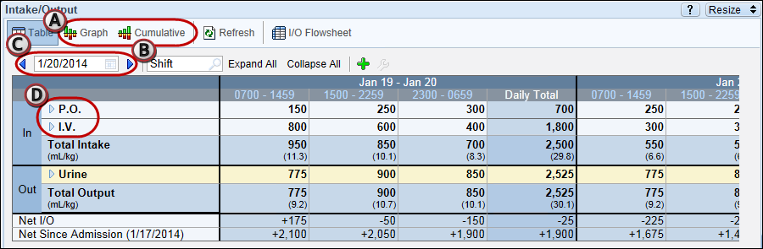

Review a patient's current infusions

IV medications and fluids automatically appear on the Intake/Output flowsheet. You can document administrations and intake directly from these flowsheet rows.

A. Maintenance fluid infusion group (includes rate and volume).

B. IV piggyback infusion group (includes dose and volume).

C. A completed infusion group. Groups are automatically completed when their orders are discontinued.

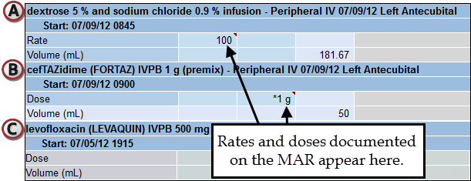

Start an infusion

Start documenting a maintenance IV or medication drip on the MAR, just as you document other medications. To change the rate or stop the infusion, use Doc Flowsheets.

1. Scan the patient's wristband and the IV bag.

|  |  |
| --- | --- |
| Important Note | If the IV was mixed by the pharmacy, scan the pharmacy label's barcode, not the manufacturer's. |

1. In the Link Lines window, select a line and click Link.

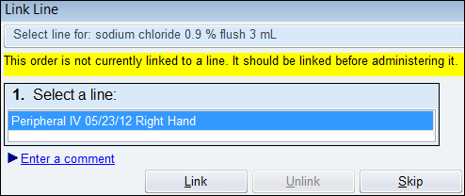

|  |  |
| --- | --- |
| Important Note | If the patient's line isn't listed in the Link Lines window, you need to document it. Refer to p. 46 for more information about documenting lines. |

1. In the administration window, document administering the IV with an action of New Bag.
2. When the information in the administration window is correct, click  Accept. On the MAR, the time, action, and dose appear in a green administration bubble.

Change the rate of an infusion

1. In Doc Flowsheets, select the Intake/Output tab.
2. Find the row for the medication drip or maintenance fluid. The rate you documented on the MAR automatically appears in Doc Flowsheets.
3. Click Add Col.
4. In the Rate cell, click . The Administration window opens.
5. Document an action of Rate/Dose change.
6. Adjust the dose or rate as needed.
7. Click Accept. The new rate you entered appears in Doc Flowsheets and on the MAR.

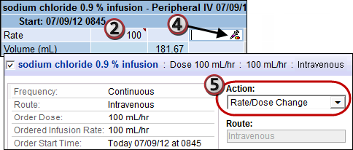

Stop an infusion

1. Select the Intake/Output flowsheet and find the rows for the IV you need to stop.
2. Insert a column for the time when you stopped the drip.
3. Click  in the rate cell. The administration window opens.
4. Document an action of Stopped and click Accept. A Stopped action appears on the MAR, and a rate of zero appears in Doc Flowsheets.

Document giving an IV piggyback or bolus

When you give an IV piggyback (IVPB), the maintenance IV stops infusing until the IVPB is finished. To keep volume estimates accurate, you must document stopping the maintenance IV when you start the IVPB. When the IVPB is finished, document restarting the maintenance IV.

Document starting the IV piggyback

1. On the MAR, document hanging the IVPB. The rate appears in the appropriate time column on the Intake/Output flowsheet.
2. Document stopping the maintenance IV at the same time that you started the IVPB.

Document stopping the IV piggyback

1. Select the Intake/Output flowsheet.
2. Insert a column for the time when the piggyback stopped infusing.
3. In the Rate cell for the IVPB, click . Document an action of Stopped.
4. In the Rate cell for the maintenance IV, click .
5. Document an action of Restarted.

Document intake from IVs

The system can automatically calculate the volume of intake from each IV based on the documented rate and the time that has passed. When you document intake, you need to verify that each calculated volume is correct.

For each IV listed on the Intake/Output flowsheet, do the following:

1. In the volume row, click . The system calculates the appropriate volume.
2. Verify that the volume is correct.

* If it's incorrect, click Cancel and enter the volume manually.

1. Click Accept.

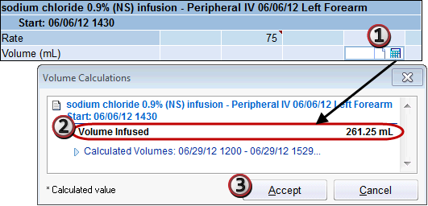

Document a PCA med

For patient controlled analgesics (PCAs), use the MAR only to document starting the med. Document the basal rate, loading dose (if one is ordered), number of doses given, and any other details in Doc Flowsheets.

1. Scan the patient's wristband and the PCA med. The Administration window opens.
2. Document an action of New Bag (or New Syringe/Cartridge, as appropriate).
3. In the PCA Settings section, enter the loading dose, patient bolus dose, lockout interval, and other details to match how you’ve set up the pump. Use the Order Questions/Answers sections to review the ordered dose and rate information.
4. Leave all other fields blank and click Accept.

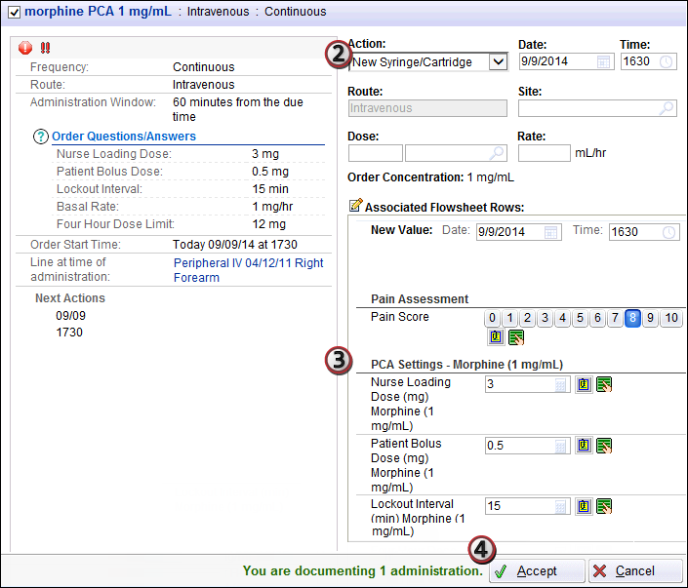

1. Select the Intake/Output flowsheet to see the PCA medication group.
2. Document the basal rate, patient bolus dose, lockout interval, and other details in the appropriate rows.
3. Continue to document the number of doses given over a period of time, the number of attempts, and the total volume infused.

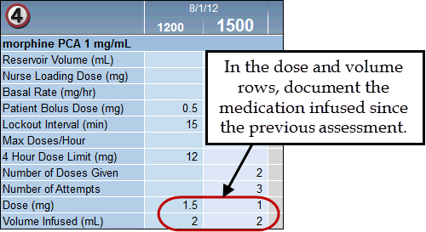

Admit a Patient

Use the Admission Navigator to complete your admission documentation. Information that you document in a navigator appears in other areas of the patient's chart, such as Doc Flowsheets.

1. In a patient's chart, open the Navigators activity and select the Admission tab.
2. Work through all the navigator sections to complete your admission documentation.
   1. Click a name of a navigator section to open it.
   2. Jump to a section by clicking it in the table of contents.

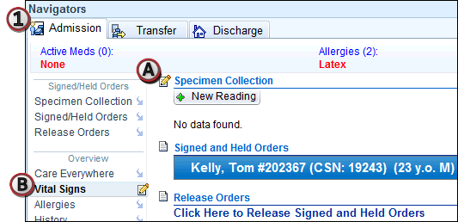

Release orders to be carried out on this unit

Sometimes a physician writes orders to be carried out after the patient is admitted to the unit. To do this, she signs and holds the orders.

The nurse on the admitting unit must release these signed and held orders AFTER the patient arrives on the unit. This ensures that medications are dispensed to the correct place, that lab labels print in the appropriate unit, and so on. You can't act on orders until you have released them.

1. Open the Release Orders navigator section.
2. In the Release Orders activity, select the check boxes next to the orders that should be carried out on this unit.
3. Click Release. The orders are now active and can be carried out.

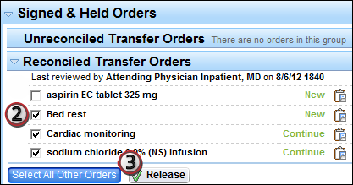

Understand phases of care

Sometimes signed and held orders have phases of care assigned to them. Phases of care tell you when to release and carry out the order. For example, only release orders with a post-op phase of care when the patient is in the PACU.

|  |  |
| --- | --- |
| Important Note | Only release orders when the patient is in the phase of care indicated by the order. |

Document allergies

1. In the Allergies section, enter the first few letters of an allergen in the Add a new agent field and press ENTER.
2. Enter details of the new allergy, such as type and reaction, and click  Accept.
3. If you verbally reviewed the allergies with the patient, click Mark as Reviewed.

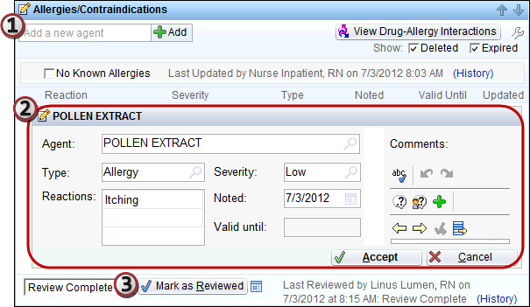

Document patient history

In the History navigator section, fill in the patient's history.

Document medical and surgical history

* Click Yes to document a history of a problem
* Click No to document a pertinent negative.
* To clear a button, click it again.
* Search for other problems in the Add field.

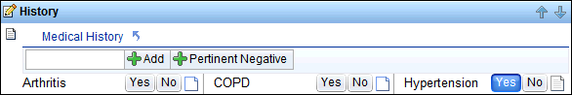

Document family history

* Enter the name and status of each relative.
* Indicate a pertinent positive by clicking the cell at the intersection of the relative and the problem.
* Indicate a pertinent negative using the Neg Hx row at the bottom.
* Leave a comment by right-clicking in a cell. View a comment by hovering your mouse over the cell.
* If you verbally reviewed the history with the patient, click  Mark as Reviewed.

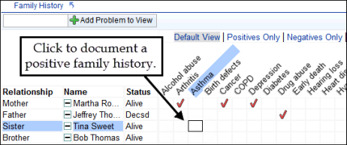

Review prior to admission (PTA) medications

PTA medications include outpatient prescriptions ()and patient-reported meds ().

1. Verbally review PTA meds with the patient. Select the Taking? check box if the patient is taking the med.
2. Use the time buttons to document when the patient last took the med.
3. If you've verbally reviewed all meds with the patient, click  Mark as Reviewed. If you can't finish the review, change the Med List Status as appropriate.

|  |  |
| --- | --- |
| Tip | Mark today or yesterday as the most recent dose for all unselected meds using the Mark Unselected buttons. |

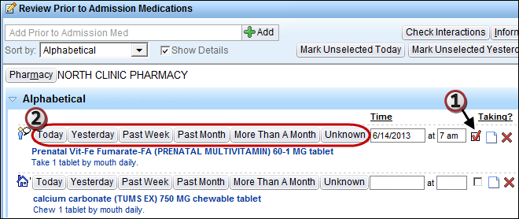

Add a PTA med to the list

1. Enter a few letters of the med name in the Add Prior to Admission Med field and press ENTER. A list of matching meds appears. Double-click the correct med.

* If you can't find the exact med, select the Database Lookup tab to see more options. Many of these meds don't have defined doses, routes, or frequencies, so you'll have to enter that information.
* If the patient doesn't know what the med was or you can't find the correct med, search for "unknown," select Unknown to patient or Unable to find, and enter as much information as possible.

1. Update the details of the medication and indicate when the medication was last taken.

Remove a PTA med from the list

Click  next to the med. If the patient is no longer taking the med, click Flag for Removal and enter a reason for the physician. If the med was added in error, click Remove Now. When you're finished, click Accept.

Complete first assessments

Use navigator sections to complete the rest of your documentation, including vital signs, screenings (Nutrition, ADL, Psychosocial, etc.), Fall Risk and Braden Scale assessments, and the Head to Toe Assessment.

|  |  |
| --- | --- |
| Tip | You can import data from a device to quickly document the latest results in a navigator. Open a flowsheet navigator section, such as Vitals, and click Pull Device Data to import the latest device data into the navigator. |

Consider clinical suggestions

BestPractice Advisories sometimes appear based on the values you document. These are suggestions about patient care that might have been overlooked. For example, a smoking cessation advisory might appear for a patient who reports tobacco use. If there are advisories for a patient, the BestPractice Advisories section appears in yellow.

1. Open the BestPractice Advisories section and fill out any required details.
   1. To do what the advisory suggests, click  Accept.
   2. If you don't want to take the action the advisory suggests, clear the check box and enter an Acknowledge Reason. Click Accept.

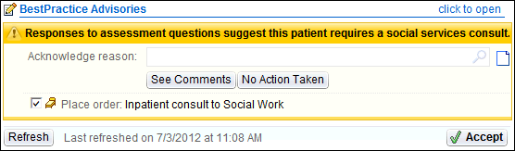

Confirm required documentation is complete

In Patient Lists, you can easily see whether a patient's required documentation is complete. If the patient has an  or  icon in the Req Doc column, the patient's required documentation is late. Click the icon to jump to the appropriate activity to complete the documentation. The missing information is marked with  or .

Document Care Plan and Patient Education

Create a care plan

Use templates to create a care plan for each of your patients. Some templates might be added automatically based on the patient's problem list.

1. In the Care Plan activity, click  Apply Template.
2. In the Template field, search for a care plan template and press ENTER. Select the appropriate template and click Accept.
3. Click Select All. Clear the check boxes next to anything that doesn't apply to your patient.
4. Click Accept. The template appears in the Care Plan window.

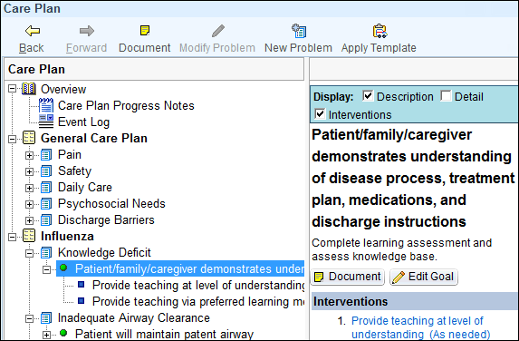

|  |  |
| --- | --- |
| Important Note | You can only remove a template by deleting all of the problems within it. |

Set an end date for a goal

To document your expected end date for a goal, select a goal in the care plan, click  Edit Goal, and enter an end date. This informs other caregivers about the expected timeline and reminds you to document on the goal when the end date arrives.

Add a new problem, goals, and interventions

1. Click New Problem.
2. Search for a problem in the Problem field. Select the one you want and press Enter.
3. To add goals to aim for, click Add Goal, search for the one you want, and click Accept.
4. To add interventions to accomplish the goals, click Add Intervention, search for the one you want, and click Accept.
5. When you're finished, click Accept. The problem, goals, and interventions appear in the Care Plan window.

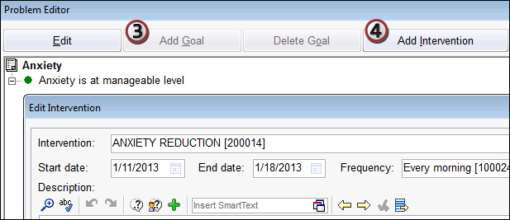

|  |  |
| --- | --- |
| Tip | To edit an existing problem, click  Modify Problem. The Problem Editor opens so you can add or delete goals and interventions and customize their details. |

Document progress on the Care Plan

Document on one goal

1. Select a goal and click  Document. The goal opens.
2. Select the goal's status from the Outcome menu.
   1. If a goal wasn't met, click  Add Variance. Select a variance, add an explanation, and click Accept.
   2. If a goal is progressing or completed, add comments to document the progress.
3. Click Accept/Summary. If you added a variance, it's saved as a Plan of Care note. Click File.

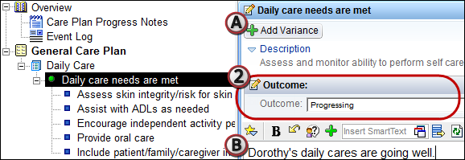

Document on multiple goals

1. In the Care Plan activity, click  Resolve Problems on the main toolbar.
2. At the bottom of the screen, click Select All Problems or select the problems one by one.
3. Document an outcome for each goal.
   1. To select different outcomes for each goal, use the field next to each goal.
   2. To apply one outcome to all goals or all goals without outcomes, select the outcome from the Outcome field at the top of the window. Then click Apply to All Goals or Apply to Goals With No Outcome as appropriate.
4. Click Accept.

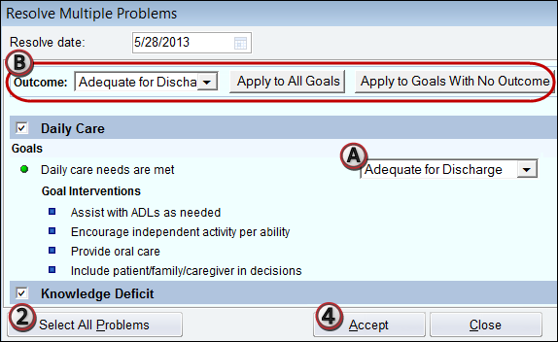

Complete a learning assessment

Before educating a patient, document a learning assessment.

1. Open the Patient Education activity.
2. On the Assessment tab, click Create New.
3. Verbally review the questions with the patient and any co-learners, such as a parent or spouse.
4. Document the answers by selecting all check boxes that apply.
5. When you are finished, click File.

Add education topics

To add a topic, click the Manage Education tab in the Patient Education activity.

1. Click Add Title at the bottom of the screen and search for a keyword.
2. Select the title you want and click Accept. The Add Education Title/Topic window opens.
3. Select the first check box. All the other check boxes are automatically selected.
4. Clear the check boxes to remove any unnecessary topics and click Accept. The topics appear on the Unresolved Education tab.

Document educating the patient

1. Select the point you want to document on.
2. Review the description of the teaching point and check for links to educational materials.
3. Using the Learner, Readiness, Method, and Response links, document how you educated the patient. A  icon appears next to the teaching point to indicate that it's complete.

|  |  |
| --- | --- |
| Tip | Click Apply Defaults to indicate that the patient showed acceptance and verbalized understanding of your explanation. |

|  |  |
| --- | --- |
| Tip | Click Multiple to quickly document progress on multiple teaching points or with multiple learners. Use this button only when all learners demonstrate the same understanding. |

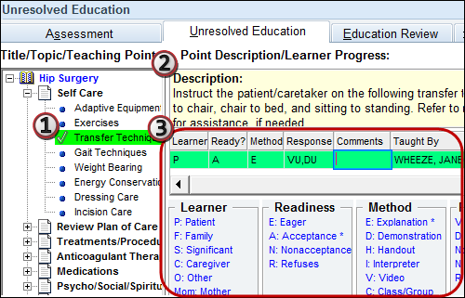

Transfer a Patient from Another Unit

Confirm a patient's arrival in your unit

To find incoming transfer patients, select the  Unit Manager tab. Incoming transfer patients appear in the Incoming Transfers section in the lower left corner.

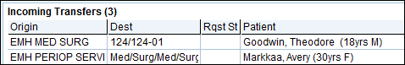

1. In the Incoming Transfers section, select the patient who arrived.
2. Click  Transfer on the main toolbar. The Transfer window opens.
3. Enter the date and time and make sure the bed is correct.
4. Click Transfer at the bottom of the screen.

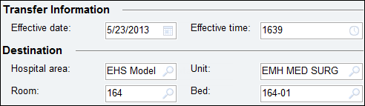

|  |  |
| --- | --- |
| Tip | Assign yourself to the transferred patient's treatment team. Open Patient Lists and find the transferred patient on your unit's list. Right-click the patient and select Assign Me. The patient appears on your All My Patients list. |

Make sure the physician reviewed medications

Physicians must review all of a patient's orders before transfer (medication reconciliation).

1. Open the Transfer navigator to the Med Rec Status section.
2. If orders appear in the Orders Needing Review before Transfer section, contact the physician for a decision about whether to continue them in the new unit.

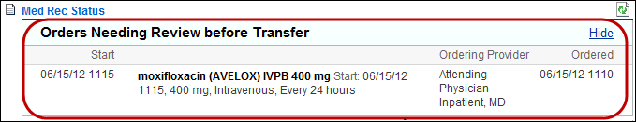

Release orders after a transfer

The patient's transfer must be confirmed in the Unit Manager before you release the orders. If the transfer isn't complete, all orders will be routed to the original unit when you click Release.

|  |  |
| --- | --- |
| Page Reference Tip | For more information about releasing signed and held orders, refer to p. 59. |

Manage Orders

To enter orders, select the Orders activity tab. Here, you can see all of the patient's current orders.

Enter a new order

Use the Orders sidebar on the right to enter new orders.

1. Enter the first few letters of a medication or other order in the Place new order field and press ENTER.
2. Double-click the correct order. It appears in the sidebar under the New Order header.

|  |  |
| --- | --- |
| Tip | If you don't see the order you want on the Preference List tab, click the Facility List tab to see more options. Also, make sure that you're spelling the medication name correctly. When in doubt, enter fewer letters. |

1. To edit details of the order, click it. (The details open automatically if information is required.)
2. When you've made all necessary changes to the order, click  Sign.

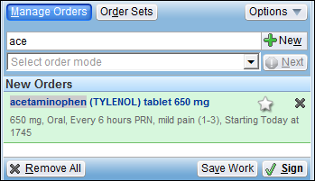

1. In the Providers window, enter the order mode, such as Telephone with readback.
2. Enter the ordering and authorizing providers. If you can't find the correct provider, clear the Filter providers by treatment team members check box.
3. Click Accept. The orders are now active.

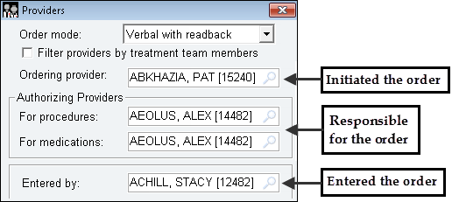

Modify or discontinue an order

A. To discontinue an order, click Discontinue. The order is crossed out and appears under the Orders to Discontinue header in the sidebar.

B. To modify an order, click Modify. The order appears under the Orders to Modify header in the sidebar and the Order Composer opens. Edit the details and click Accept when you're finished.

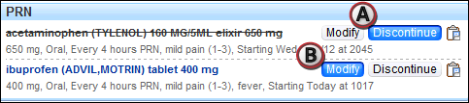

Enter several similar orders at once

Order Sets are groups of orders that are commonly placed together. There are Order Sets for many common situations, such as pneumonia admissions and abdominal surgeries.

1. In the Orders sidebar, click Order Sets. The Order Sets activity opens on the left side of the screen.
2. Search for an Order Set in the Order Sets Search field. Matching Order Sets and suggestions based on the patient's Problem List appear below the search field.
3. Select the check box next to the Order Set you want.
4. Click Open Order Sets.

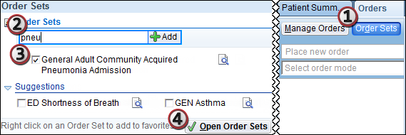

1. Go through each category and select the orders you want. If a section is required, you must select at least one option. Orders you select appear in the Orders sidebar.
2. Modify the selected orders as necessary.
3. When you are finished, click  Sign.

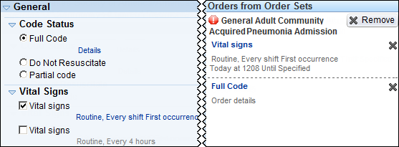

Discharge a Patient

Work through all sections of the Discharge Navigator to complete your discharge documentation.

A. Overview Report: Shows discharge orders, unresulted lab tests, and other information relevant to discharge.

B. Running Infusions: Shows any infusing meds. Click the Open MAR link to document stopping them.

C. LDA Removal: Lists the patient's remaining LDAs. To document removing them, click the Remove Now link. Document site assessments as usual in Doc Flowsheets.

D. Med Rec Status: Make sure that the physician reviewed the discharge orders in this section. Unreviewed orders appear under Discharge Medications Needing Review.

E. Patient Instructions: To write discharge instructions, add comments to this section. You can use SmartTools in any of the comment fields.

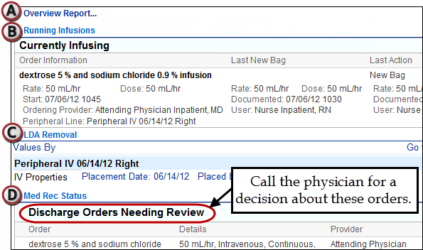

Sign up a patient for MyChart

To encourage patients to stay involved in their care, ask them to sign up for a MyChart account during discharge. With a MyChart account, patients can review their upcoming appointments, lab results, current medications, and more online.

1. In the MyChart section of the Discharge Navigator, click  MyChart Sign-up. Your Hyperspace session is secured and the MyChart Signup Page opens in a browser window.
2. Ask the patient to follow the instructions on the screen to set up a MyChart account. When the steps are completed, the MyChart account opens.
3. Ask the patient to log out so you can continue charting.

|  |  |
| --- | --- |
| Tip | If a patient doesn't want a MyChart account, click Patient Declined. |

Print a visit summary for the patient

The After Visit Summary (AVS) contains the patient's discharge instructions and a list of meds to take at home. It is automatically generated from the information you and the physician enter in the Patient Instructions topic of the Discharge Navigator.

1. In the Preview After Visit Summary navigator section, click the Click the Preview After Visit Summary link.
2. Review the AVS. Unresolved patient issues appear at the top of the AVS preview window.
3. Click Print to print the AVS.

Nurse Cheat Sheet

| Keyboard Shortcuts | |
| --- | --- |
| TAB | Move to the next field. |
| SHIFT+TAB | Move to the previous field. |
| CTRL+C | Copy selected text. |
| CTRL+V | Paste text that you copied. |

| Flowsheet Keyboard Shortcuts | |
| --- | --- |
| SHIFT + up arrow | Move up one group in the flowsheet |
| SHIFT + down arrow | Move down one group in the flowsheet |
| PAGE UP / PAGE DOWN | Scroll up or down about one screen at a time |

| Flowsheet tips | |
| --- | --- |
| Weight units | Enter "lb" for pounds or "kg" for kilograms |
| Height units | Enter "f" for feet, "i" for inches, or "cm" for centimeters |
| BP shortcut | Enter a space instead of / (for example, 120 80) |

| Navigator Keyboard Shortcuts | |
| --- | --- |
| F7/F8 | Open the previous/next navigator section |
| F9 | Open or close the current navigator section |
| ALT + up/down arrow | Move up or down through the navigator's table of contents. Release the ALT key to open the selected section. |

| **Epic Quotes** | |
| --- | --- |
| **“Hover to discover!”** | Point your mouse over information to see  more details |
| **“F8 to Navigate!”** | When in a Navigator, press F8 on your  keyboard to jump to the next section |
| **“Right click to pick it,**  **left click to stick it!”** | On the docked details report in flowsheets,  right click in multiple select option to choose  what you want to document. Then left click to  jump to the next flowsheet row |

Important Telephone Numbers

Write your Help Desk or other support numbers here.

|  |
| --- |
|  |
|  |
|  |
|  |